REPORT ON INTER-COLLEGE OPEN MIC AND SPEECH COMPETITION
"Mera Vote, Meri Zimmedari"

Introduction
To instill awareness among the youth regarding their voting rights and duties, an Inter-College Open Mic and Speech Competition titled "Mera Vote, Meri Zimmedari" was organized on 29th January, 2025 at the College Seminar Hall. The event was graced by esteemed guests Dr. Shubhnoor (SDM, District Election Office, Shahdara, Delhi) , Principal Prof. Nachiketa Singh,Ms. Manju Kohli (Nodal Officer), and Dr. Manoj Kumar (Convenor) who shared their valuable insights on the significance of electoral participation.
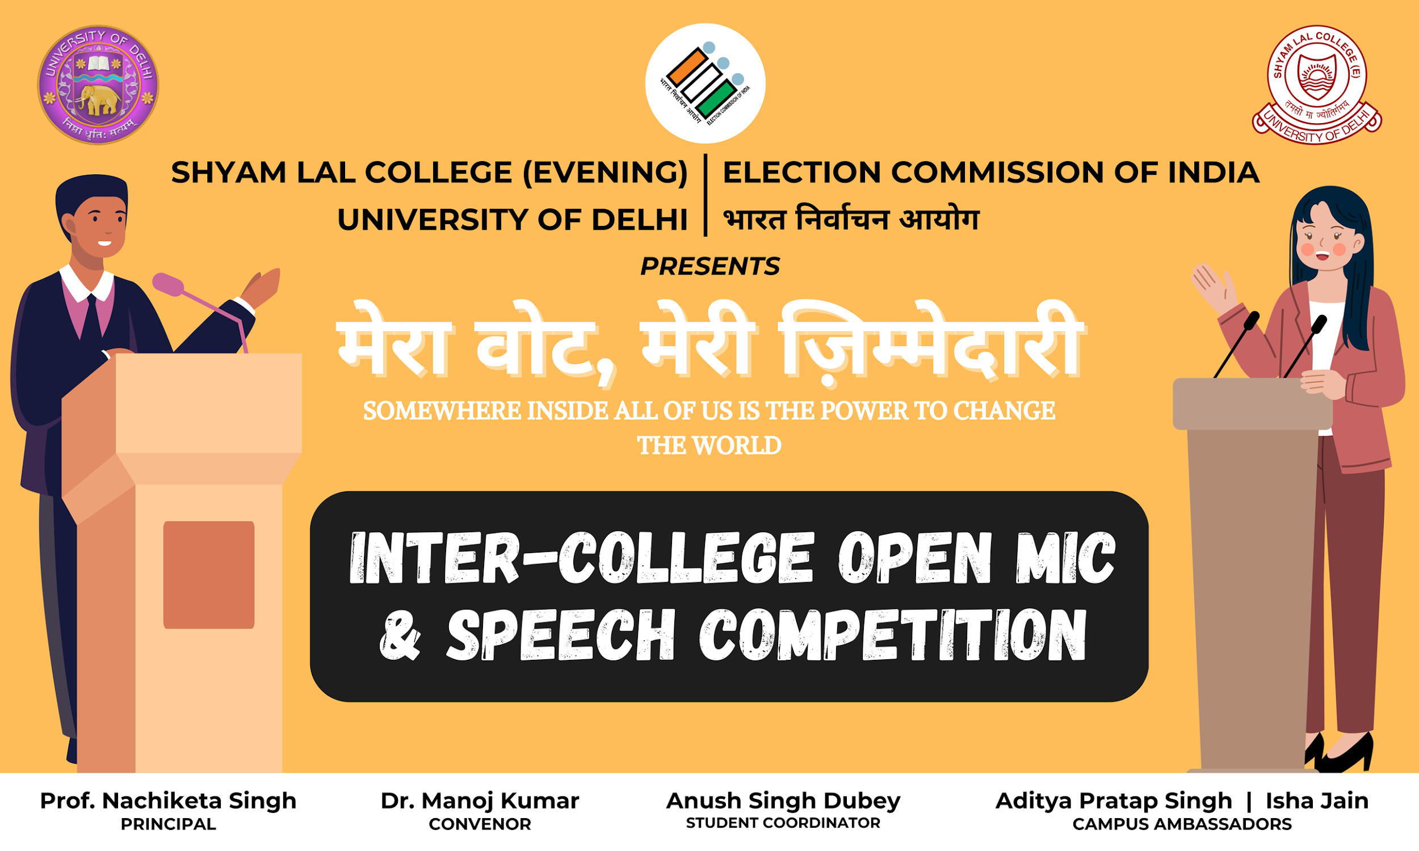

Proceedings of the Event
1. Welcoming the Guests and Audience
The event commenced with a warm welcome extended to the chief guests, the principal, faculty members, students, and all attendees.
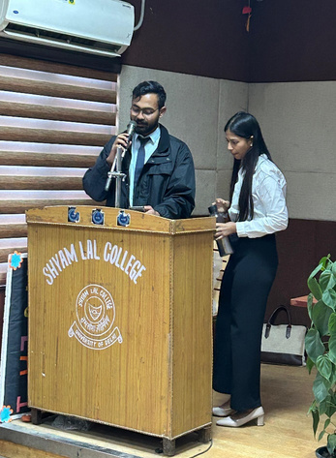

2. Lamp Lighting
As a symbol of knowledge and enlightenment, the ceremonial lamp was lit by the chief guests, signifying the commencement of the program.
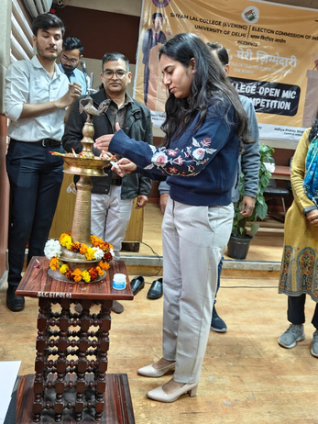

3. Speech by the Chief Guest
Dr. Shubhnoor delivered an insightful speech emphasizing the fundamental role of youth in strengthening democracy. She highlighted the importance of voter awareness and ethical electoral participation.
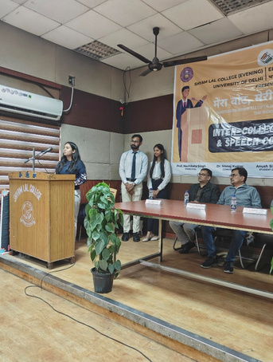

4. Address by the Principal
The principal addressed the gathering, reinforcing the necessity of being informed voters and responsible citizens. He encouraged students to actively engage in the democratic process.
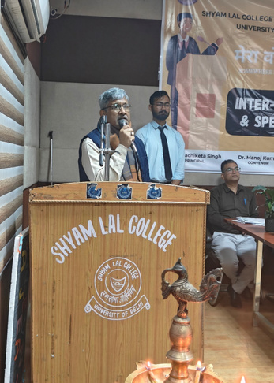

5. Felicitation of the Chief Guests
As a token of respect and appreciation, saplings and shawls were presented to the chief guests by the principal, acknowledging their invaluable contributions to electoral awareness.
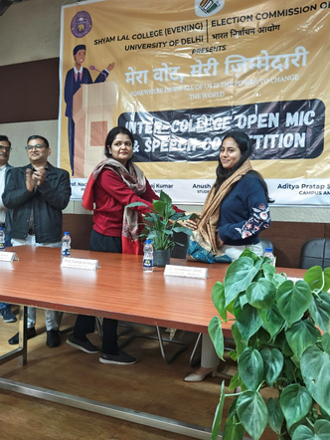
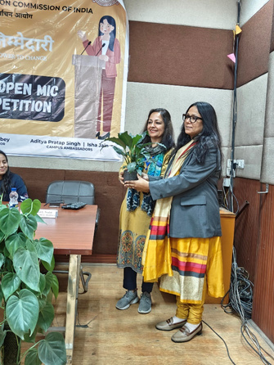

6. Speech Competition
The Speech Competition witnessed the participation of 36 students, who eloquently expressed their perspectives on voting rights and civic responsibilities. Their speeches reflected deep understanding and commitment towards democracy.
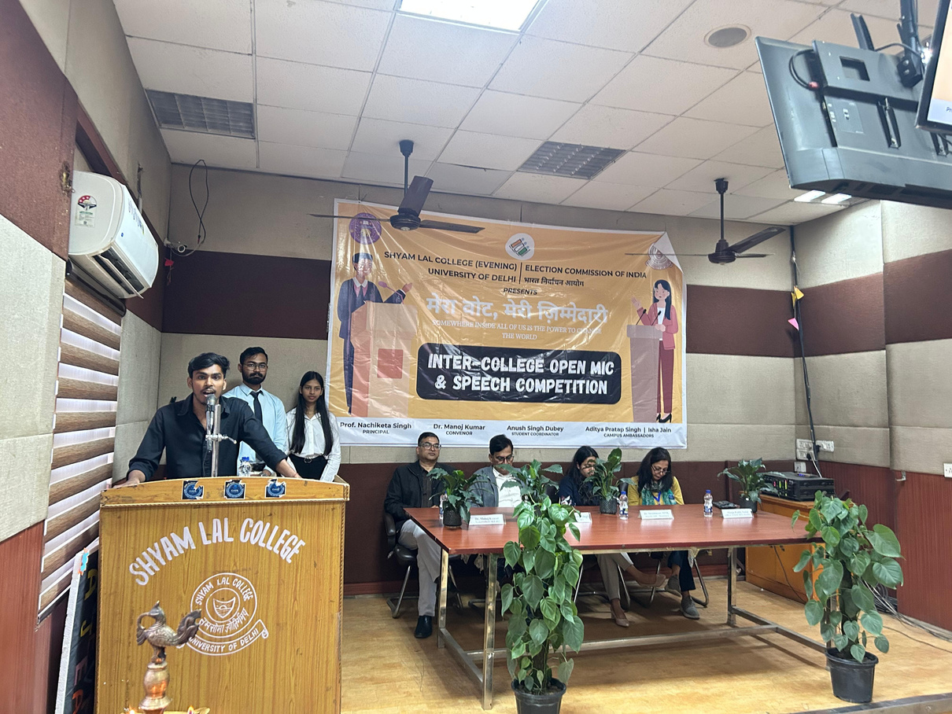

7. Open Mic Competition
Following the speech competition, 12 participants took the stage in the Open Mic Competition, engaging the audience with thought-provoking poems, monologues, and personal anecdotes related to voting awareness.
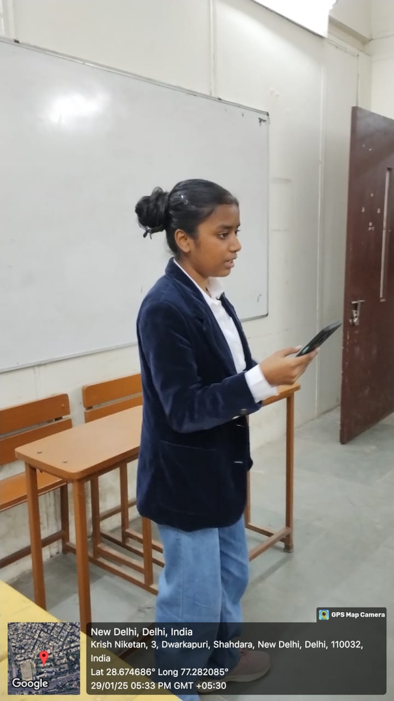

8. Announcement of Winners and Prize Distribution
The most outstanding participants from both competitions were awarded certificates and trophies as a recognition of their exemplary performances.
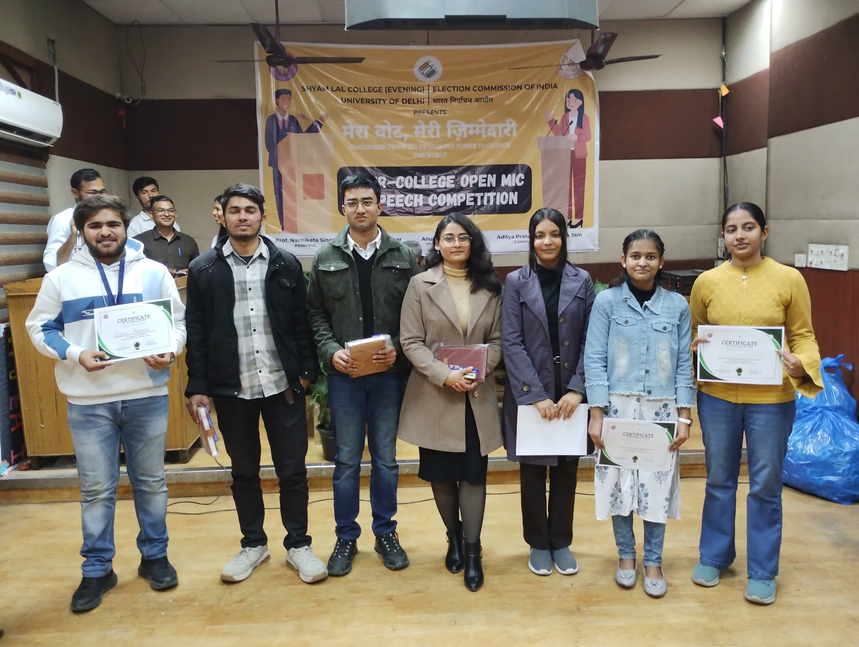

9. Vote of Thanks
The Convenor Dr. Manoj Kumar delivered the Vote of Thanks, appreciating the exemplary contributions of:
- Chief Guests for their presence and insightful speeches.
- Principal for his continuous encouragement.
- Organizing Faculty: Dr. Vatsal Singh & Dr. Roli Raghuvanshi, for their dedicated efforts in planning and execution.
- Judges of the events: Ms Ila Bhushan Jain, Dr. Ram Roop Meena, Dr. Sanjeev Kumar Sharma for speech competition and Dr. Vatsal Singh, Dr. Roli Raghuwanshi and Ms S. Sruti for open mic competition.
- Organizing Student Body: Aditya Pratap Singh (Campus Ambassador, ECI), Isha Jain (Campus Ambassador, ECI), and Anush Singh Dubey (Student Coordinator), for their proactive role.
- Teaching & Non-Teaching Staff, Participants, and the Audience for making the event a grand success.
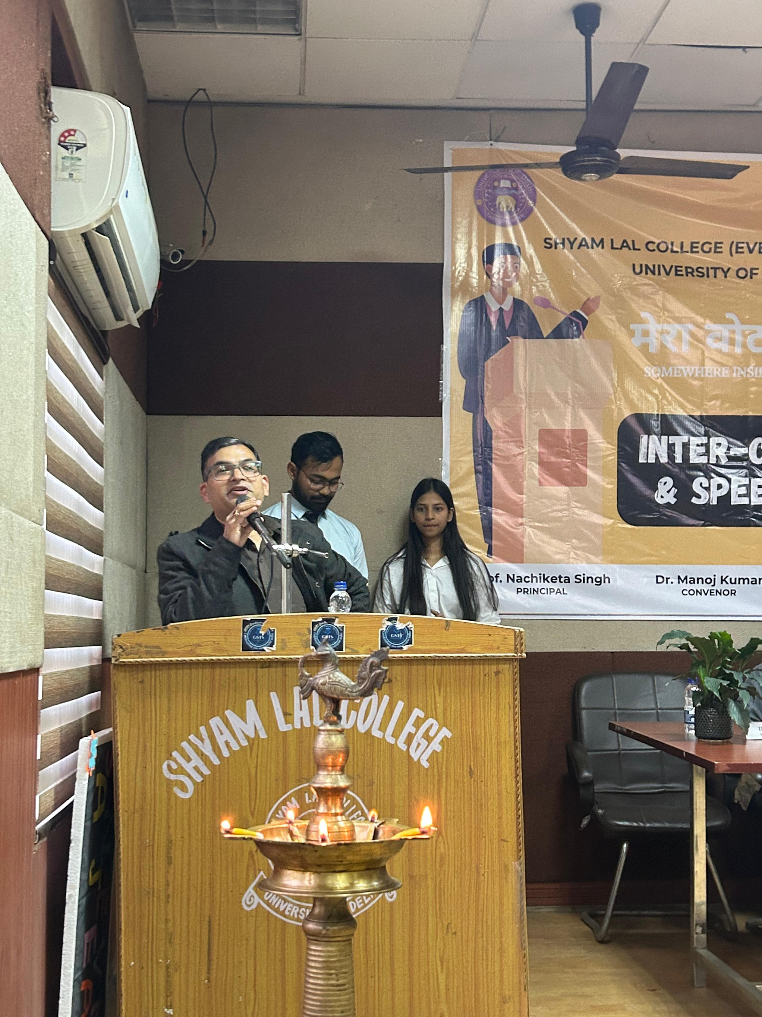

10. Election Awareness Rally
The event concluded with a rally promoting election awareness, where students actively participated in spreading the message of responsible voting through slogans and placards.
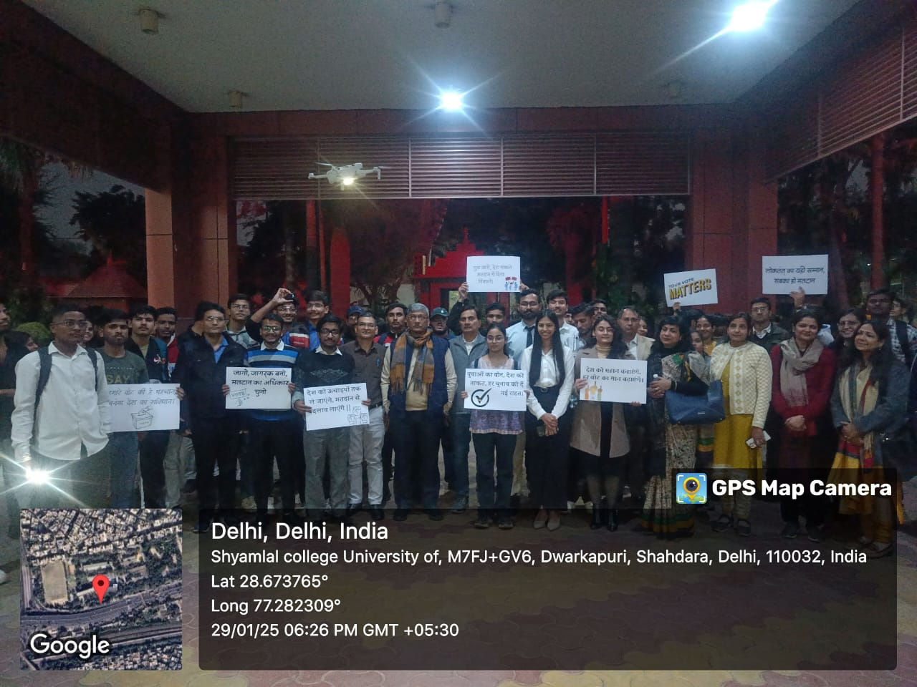

Conclusion
The "Mera Vote, Meri Zimmedari" competition successfully ignited a sense of electoral responsibility among students. Through engaging speeches, artistic expressions, and an awareness rally, the event reinforced the power of voting in shaping the nation's future. The initiative served as a strong reminder that every vote counts, and every voter matters.

